**How to install Python Pycharm on Windows?**

Last Updated: 11 Oct, 2023

Python is a programming language that lets you work quickly and integrate systems more efficiently. We need to have an interpreter to interpret and run our programs. There are certain online interpreters like ***GFG-IDE, IDEONE CodePad,***etc. Running Python codes on an offline interpreter is much more compatible than using an online IDE. In this article, we will learn ***How to install Python Pycharm on Windows.***

PyCharm is one of the most popular**Python-IDE** developed by JetBrains and used for performing scripting in Python language. PyCharm provides some very useful features like Code completion and inspection, Debugging process, support for various programming frameworks such as Flask and [Django](https://www.geeksforgeeks.org/django-tutorial/), Package Management, etc. PyCharm provides various tools for productive development in [Python.](https://www.geeksforgeeks.org/python-programming-language/)

**How to install Python IDE?**

Before, starting with the process of Installing Python IDE PyCharm in Windows, one must ensure that Python is installed on their system. To check if the system is equipped with Python, go to the Command line(search for cmd in the Run dialog( window button + R).

Now run the following command on cmd:

python --version

If Python is already installed, it will generate a message with the Python version available.

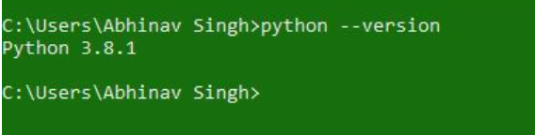

If Python is not present, go through [How to install Python on Windows?](https://www.geeksforgeeks.org/how-to-install-python-on-windows/)and follow the instructions provided.

## How to Install Pycharm?

Here is a process to download Pycharm :

**Step 1)** Go to website official website of Jetbrains <https://www.jetbrains.com/pycharm/download/>and click on the “DOWNLOAD” link of the Community section.



**Step 2)**After clicking on Download Click on Next

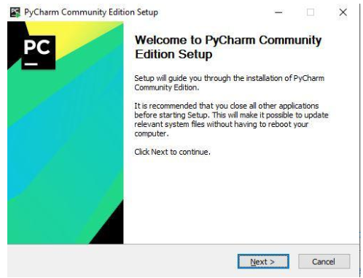

**Step 3)** After Click on Next, you need to choose the destination folder according to your choice.

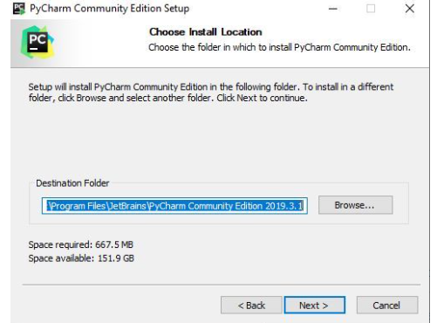

**Step 4)**Choose options of installation according to your choice.

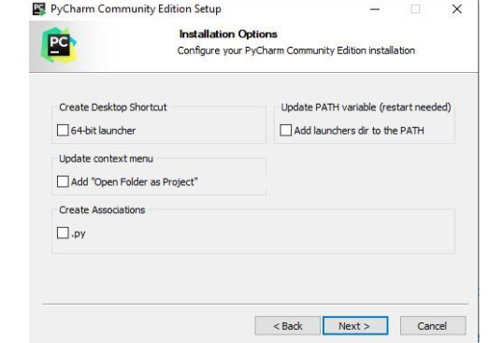

**Step 5)**Choose JetBrains and Click on “Install”.

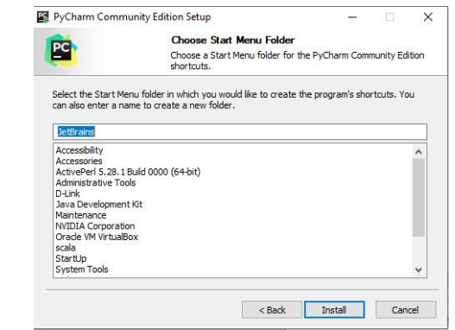

**Step 6)**Let the installation finished.

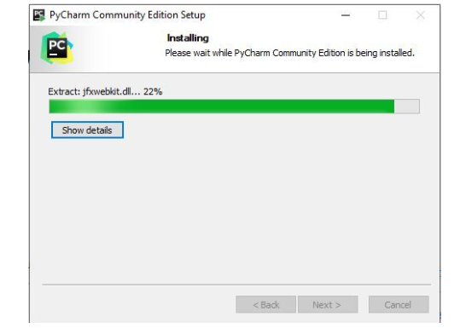

**Step 7)**After Installation completed, It will show that Pycharm is installed successfully, then click on “I want to manually reboot later”. Click on Finish and then the process is completed.

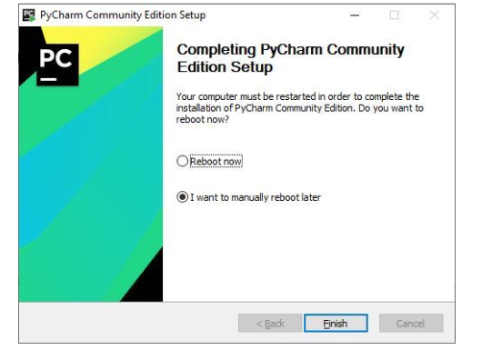

## Getting Started with PyCharm

Once the Installation is over, PyCharm can be searched and started from the Start Menu. Follow the steps given below to do the same:

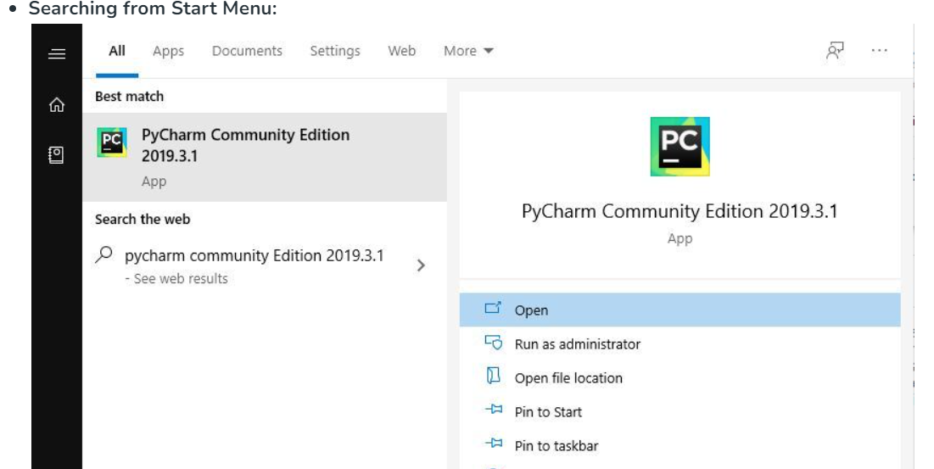

**Getting done with License Agreement**

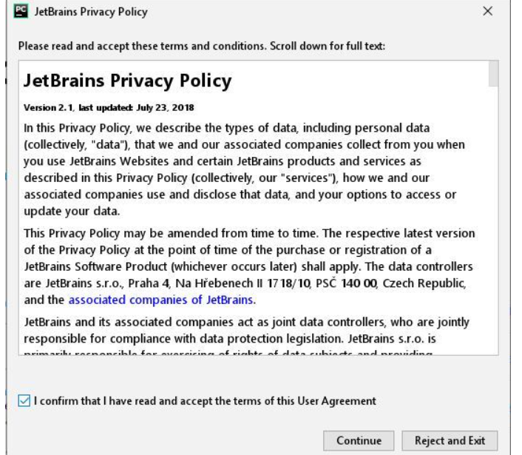

**Setting UI Theme:**

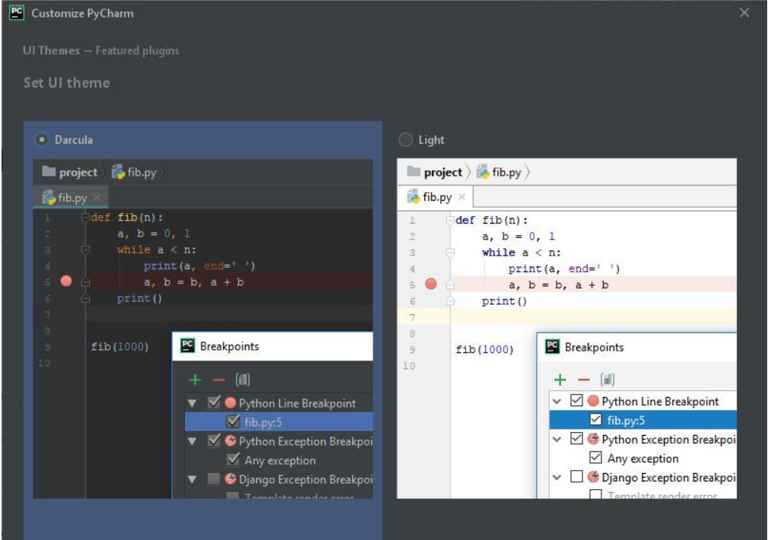

**Downloading Plugins:**

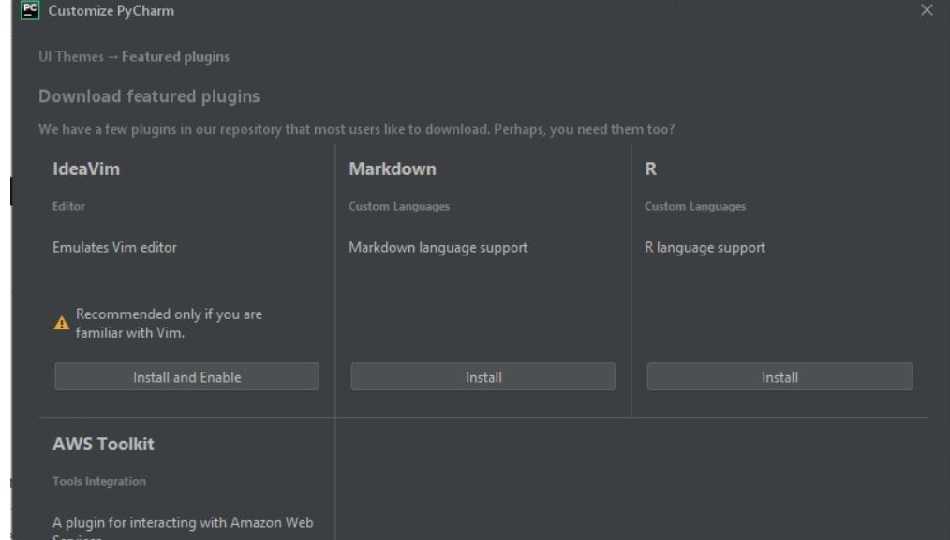

**Get Started with PyCharm:**

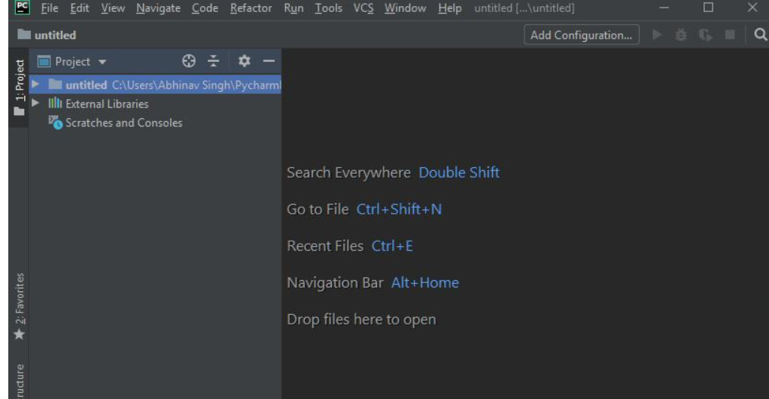

**Now Add Pyautogui in Pycharm**

To add Pyautogui to PyCharm, you can use the built-in package manager to install it. In PyCharm, go to File > Settings > Project > Project Interpreter. Then, click the + button to open the Install Packages window. Type pyautogui in the search field and press Enter. Click the Install Package button to install it.

(OR)

To install pyautogui in PyCharm, follow these steps:

1. Open PyCharm and click on the "Settings" gear icon in the top right corner.
2. In the Settings window, click on "Project: [Your Project Name] > Project Interpreter" in the left sidebar.
3. Click the "+" button in the top right corner of the Project Interpreter window.
4. In the search bar, type "pyautogui" and press enter.
5. Select the pyautogui package from the search results and click the "Install Package" button.